Name:_________________________________________________ Date:_________________________ Class:_________
A Closer Look at News, Feature, Sports, and Op/Ed Articles
Article Headline: “Nearly 300,000 people in Carolinas without power after Irma blows through”
- What type of article is this? _________________________________________
- Can this type of article show the writer’s bias or opinions? Yes No
- Copy 3 complete sentences from the article that reflect the type of article it is:
- ________________________________________________________________________________________
________________________________________________________________________________________
- ________________________________________________________________________________________
________________________________________________________________________________________
- ________________________________________________________________________________________
________________________________________________________________________________________
Article Headline: “Exclusive: Bills coach Sean McDermott talks about how the Panthers shaped him”
- What type of article is this? _________________________________________
- Can this type of article show the writer’s bias or opinions? Yes No
- Copy 3 complete sentences from the article that reflect the type of article it is:
- ________________________________________________________________________________________
________________________________________________________________________________________
- ________________________________________________________________________________________
________________________________________________________________________________________
- ________________________________________________________________________________________
________________________________________________________________________________________
Article Headline: “Studies reveal the real value of make believe”
- What type of article is this? _________________________________________
- Can this type of article show the writer’s bias or opinions? Yes No
- Copy 3 complete sentences from the article that reflect the type of article it is:
- ________________________________________________________________________________________
________________________________________________________________________________________
- ________________________________________________________________________________________
________________________________________________________________________________________
- ________________________________________________________________________________________
________________________________________________________________________________________
Article Headline: “How counting beluga whales can help build community and trust”
- What type of article is this? _________________________________________
- Can this type of article show the writer’s bias or opinions? Yes No
- Copy 3 complete sentences from the article that reflect the type of article it is:
- ________________________________________________________________________________________
________________________________________________________________________________________
- ________________________________________________________________________________________
________________________________________________________________________________________
- ________________________________________________________________________________________
________________________________________________________________________________________

How counting beluga whales can help build community and trust
By Charles Wohlforth

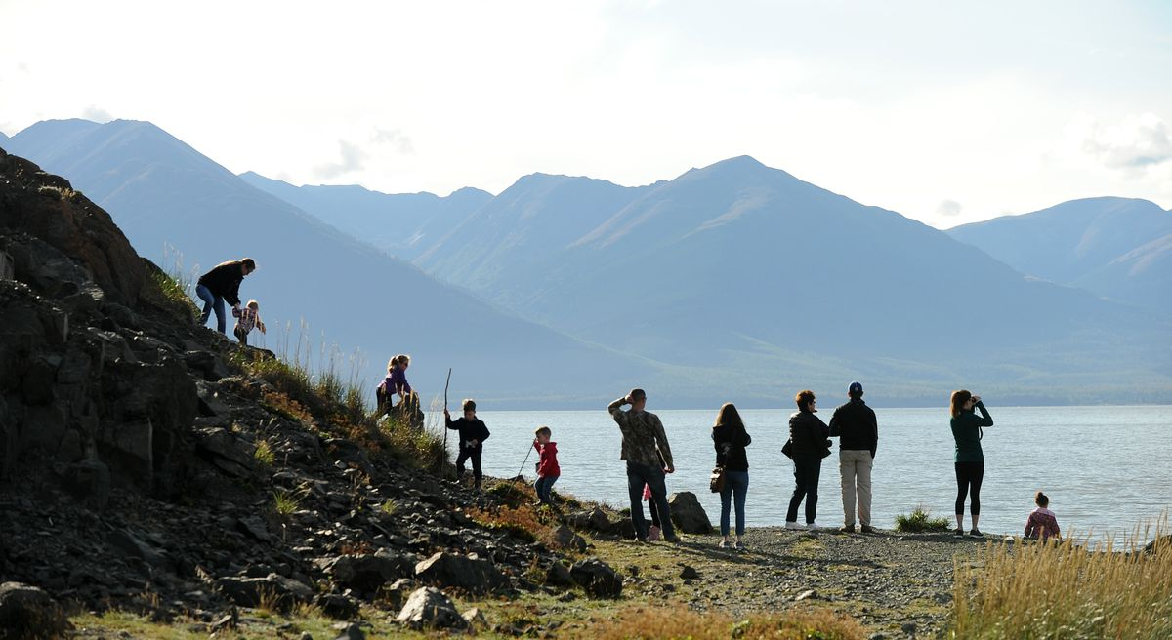
Volunteers watch for little white whales at Beluga Point along the Seward Highway during NOAA’s “Belugas Count!” event on Saturday, Sept. 9, 2017. (Bob Hallinen / Alaska Dispatch News)
My daughter and I set out for the joy of a sunny fall morning on Turnagain Arm Saturday. I came back with a sense of change in how Alaskans feel about the environment.
The pullouts were full along the Seward Highway. Some people aimed big lenses on tripods standing firmly on the pavement. Others scrambled to the water's edge.
High tide had pulled a brilliant plain of calm, gray seawater up over the mudflats, as smooth as the cover on a well-made bed. Beluga whales' white backs popped from that flat, reflective water.
Each time they did, Verena Gill's phone played a tune. Gill is a biologist with the National Oceanic and Atmospheric Administration.
With a team of agencies and conservation groups, Gill organized an event called Belugas Count!, a citizen-science effort like the Christmas bird count to involve the public in studying Cook Inlet's endangered belugas.
Whenever someone saw a whale at any of 12 stations surrounding Turnagain and Knik arms, that person sent a group text and Gill's phone sang.
As we talked at Windy Corner Saturday, a report came in of a pod of 16 whales heading past Kincaid Park, honking. Gill turned to her 10-year-old daughter, Brianna Gill-Anderson, to run the information to a group keeping records at the other end of the parking lot.
Another report. Five white whales and a gray at Point MacKenzie.
A beluga viewing station at Windy Corner on Turnagain Arm was one of 12 set up in upper Cook Inlet to encourage stewardship of the endangered whale population. (Loren Holmes / Alaska Dispatch News)
More than 1,200 people participated in the count, sighting 260 whales (although some sightings were duplicates). The most recent official count put the Inlet's total population at 328 whales, so the observers saw a good portion of how many live in our waters.
The cheer of a sunny morning and the excitement of seeing whales created a healthy buzz of smiling camaraderie. In the afternoon, counters retreated to the Alaska Zoo to hear talks, visit tables for information and munch cupcakes with beluga-shaped toppers.
I kept asking people about the controversy over the whales' Endangered Species Act listing. But folks just kept smiling.
Beluga whales were once much more common in the Inlet, with a count of 1,300 in the 1970s. The population crashed, apparently because of too much subsistence hunting, and conservationists began calling for protection 20 years ago.
Getting that protection took a long time against intense opposition from industry and Alaska's political establishment. Finally, in 2008, NOAA listed the unique Inlet population as an endangered species.
Politicians attacked the decision at the time, including Gov. Sarah Palin, Anchorage Mayor Mark Begich, Mat-Su Mayor Curt Menard and Rep. Don Young, who absurdly said the listing "ignores science," when the opposite was true.
It's a long and hallowed Alaska tradition to attack environmentalists as unreasonable, emotional and unscientific when you don't like the limitations environmental protection requires.
For decades, Alaska's environment versus development debate ran along those lines. Two sides formed in opposite trenches and used selected evidence to fire across no-man's land. Allowing the enemy's facts to change your mind would mean betraying your team.
Wishing doesn't change facts, but facts are weak in overcoming wishes.
Climate change has produced this kind of stalemate. Talking with those who deny the human role, I've found that batting away silly pseudo-science arguments may make little difference. Instead, the conversation often turns to the importance of freedom.
For some, the international cooperation needed to slow the changing climate smells too much like a frightening world government. With that deep distrust, it's easy to disbelieve the evidence of our impact on the climate.
More facts won't bridge this gap. The bridge needed is cultural, toward mutual acceptance and trust, and a shared appreciation for the natural world.
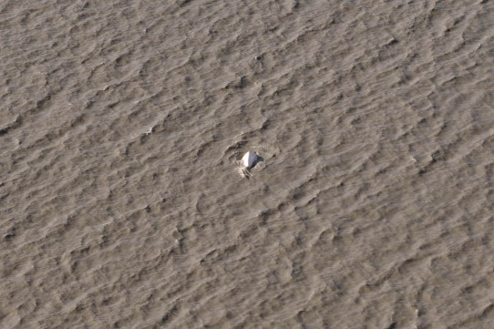
A beluga whale swims in Turnagain Arm on Sept. 9, 2017. (Loren Holmes / Alaska Dispatch News)
On Saturday morning, belugas connected everyone.
Those who predicted doom for development in 2008 when belugas were listed have been proven wrong. Meanwhile, the value of the animals is undeniable if you love our region.
Suzanne Steinert, a graduate student who led the count at Girdwood, said she has encountered none of the controversy about beluga protection. As part of her graduate studies of the whales, she started the Beluga Whale Alliance in June to advocate for them.
"From what I've experienced so far, it's overwhelming positive support. It's really, like, incredible," she said. "I think people here do really value their presence. I think there really has been an increase in pride in that. . . People do care about them and want to support their conservation."
Back at the zoo, current Anchorage Mayor Ethan Berkowitz spoke enthusiastically to the whale lovers. His basic point suggested the change in how we deal with these issues.
"We live in a time when facts matter," he said. "When we make policy about places that we live, it is important for us to do it on the basis of a real understanding of how many whales there are."
He continued, "There are a lot of development pressures in this state. There are a lot of challenges to doing things the right way. But we cannot make decisions about doing things the right way until we have the right facts."
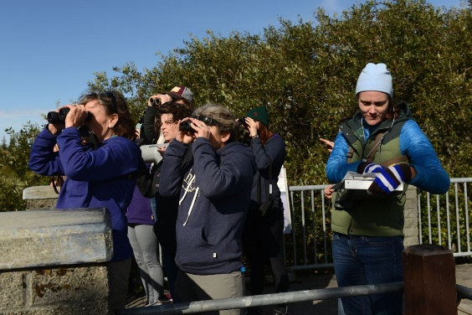
Susan Culliney, a volunteer at the NOAA beluga count, marks down four whales spotted at Bird Point on Saturday. A pod of 15 to 22 whales passed by earlier. (Bob Hallinen / Alaska Dispatch News)
Maybe Alaskans are learning to accept environmental facts more readily. I'm not sure. But I do think the debate is changing.
That's important for belugas, because their numbers are not recovering. We don't know why. It's possible a real solution to protecting them will be more costly.
Standing out in the sun counting them seemed relevant to that. Looking at whales is fun and inspiring. But more important, doing it together helps build a stronger community, and that is the basis of trust.
The views expressed here are the writer's and are not necessarily endorsed by Alaska Dispatch News, which welcomes a broad range of viewpoints. To submit a piece for consideration, email commentary(at)alaskadispatch.com. Send submissions shorter than 200 words to letters@alaskadispatch.com or click here to submit via any web browser.

Studies reveal the real value of make-believe
BY KATHY HIRSH-PASEK
The Dallas Morning News

Of course, children prefer scooping and eating real ice cream to playing with wooden cones adorned with pretend sparkles. Duh! They would like to drive real cars, too.
But just because children prefer the real deal, as research by Angeline Lillard of the University of Virginia shows, that does not negate the value of make-believe and toy play. In fact, scientific studies give us reason to believe that play serves an important role in helping children practice the storytelling skills that will build strong readers, in helping kids learn new vocabulary as in the phrase knights in shining armor who defend the castle walls, and even in preparing for STEM disciplines.
Lillard and I visited an indoor play space in Taipei where children were playing make-believe with a variety of toys. While Lillard writes that she witnessed a child who seemed bored scooping pretend ice cream, I saw a range of wonderful activities beyond wooden ice cream cones.
There were rideable little cars powered by toddler feet that took children to pretend gas stations. The little guys in those cars got to navigate around the play space floor as they headed to refuel. They had to map out where they were going. There were levers that could be carefully placed at particular slopes to send balls rolling down inclines and puzzles that helped children rotate and transform objects to fit into their proscribed locations.
Our research shows that these children are engaged in the kind of playful spatial activities that will prepare them for mathematics when they begin formal schooling.
Pretend play might also allow children to more clearly focus on the overarching story line than would be possible in real life. Those kids eating the real ice cream that is leaking out of the bottom of the cone are focusing only on the drips. In contrast, the pretend ice cream store prompted preschoolers to categorize the scoops as they carefully replace the green “mint” flavored pieces in the bin to the left and the brown chocolate “ice cream” in the bin to the right. In the pretend store, children take our play money and even give us play change from the cash register.
They are indeed learning about role play, practicing a script for buying a cone and even getting a bit of math – not that they got the change right. Lillard herself has argued that stronger language skills were a real outcome of pretend play.
No doubt, Lillard is making a broader and an important point, which is that make-believe is only a part of what it takes to grow up and to learn life skills. Real experiences are critical and we should indeed allow kids more opportunity to ride on ponies, to see the cross sections of real cut-up veggies and to talk on real phones.
But giving our children these experiences does not negate the joy of make-believe nor the value of play. Play – yes, even make-believe – enhances developmental experiences. Let’s not throw out the proverbial baby with the bath water.

Nearly 300,000 people in Carolinas without power after Irma blows through
BY MARK PRICE AND BRUCE HENDERSON
msprice@charlotteobserver.com
SEPTEMBER 12, 2017 6:27 AM
Nearly 300,000 people in the Carolinas woke up without power Tuesday after a night of gusty winds and heavy rain as what was left of Hurricane Irma moved through the states.
Two deaths, both in South Carolina on Monday, were reported.
Power outages affected 76,000 homes and businesses in North Carolina, mostly in the mountains, the state emergency management agency reported. South Carolina had more than 220,000 people without electricity early Tuesday, the Associated Press reported.
Duke Energy reported 100,000 customers in South Carolina and 60,000 in North Carolina were without power at 7:15 a.m, including more than 9,200 in Mecklenburg County.
South Carolina’s upstate counties of Greenville, Anderson and Pickens were hardest hit within Duke’s territory. In North Carolina, the mountain counties had the most outages, including the Asheville area.
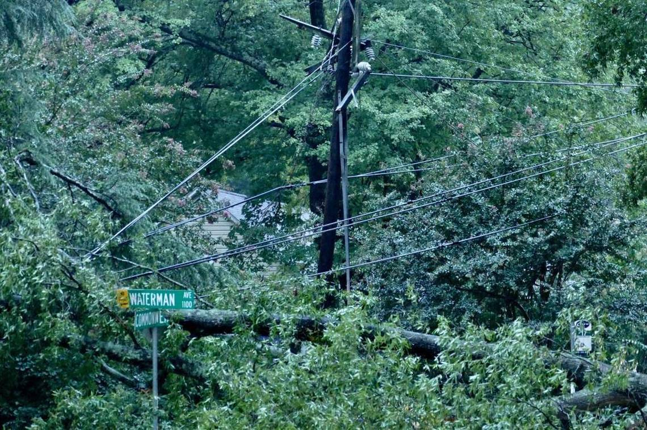
A large branch pulled down power lines and closed Commonwealth Avenue at Waterman Avenue in Charlotte on Tuesday morning.
Davie Hinshaw dhinshaw@charlotteobserver.com
In most locations, Duke said it was still assessing damage and had no estimate of when power would be restored.
News and law enforcement agencies reported more than 50 downed trees in the western Carolinas, many blocking streets and pulling down power lines. The National Weather Service reported trees down in Charlotte on Hempstead Place, Commonwealth Avenue, Pritchard Street, Beatties Ford Road and Draper Avenue.
The weather service reported maximum wind gusts of 45 mph at Charlotte Douglas International Airport and 44 mph at Carolinas Medical Center in Charlotte, both on Monday evening. Highlands, in the mountains of Macon County, logged a 56-mph gust.
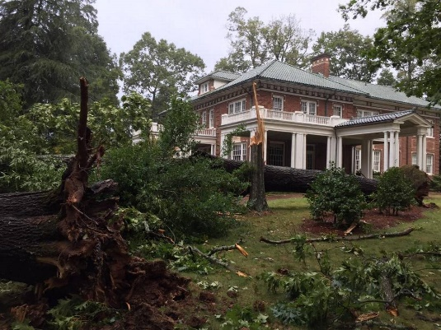
Rain and wind toppled two large oak trees at historic Stowe Manor in downtown Belmont. The trees did not damage the manor, which is used for weddings and other events. Parts of downtown Belmont remained without power Tuesday morning and Gaston County schools were closed.
Ann Doss Helms ahelms@charlotteobserver.com
Charlotte’s airport got 1.1 inches of rain from Irma, with most parts of the region and the foothills reporting less than 2 inches. Brevard and Tuxedo, in the North Carolina mountains, got 4 inches of rain. Rain was expected to taper off Tuesday.
The weather service reported no flooding, which had been a concern as Irma approached, in the western Carolinas. Great Smoky Mountains National Park, which reported wind gusts of 66 mph on its highest peaks, began to reopen roads closed due to high winds.
Charlotte-Mecklenburg Schools opened two hours late on Tuesday and officials said after-school programs would operate on a normal schedule.
The flight-tracking website FlightAware.com reported 73 flight cancellations to or from Charlotte Douglas International Airport on Tuesday. American Airlines had canceled about 350 flights out of Charlotte on Monday because of anticipated winds associated with Irma.
Authorities reported the first death in South Carolina from Irma — a 57-year-old Abbeville County man. He was cleaning limbs and debris outside his home in Calhoun Falls around 3 p.m. Monday when a limb fell on him.
Zhen Tain, 21, died in a crash on Interstate 77 east of Columbia at around 3:15 p.m. Monday. Troopers say Tain crashed into another car and his Ford Mustang flipped, trapping him inside, as heavy rain and high wind gusts lashed Columbia.
South Carolina’s coast reported the worst tidal surge since Hurricane Hugo in 1989, flooding many areas, Charleston’s Post and Courier reported. The nearly 10-foot tide was 4 feet more than normal. The city of Charleston deployed pumps Tuesday morning to the most flooded areas downtown.
Six deaths in Florida have been blamed on Irma and three in Georgia, the Associated Press reported. At least 35 people were killed in the Caribbean.

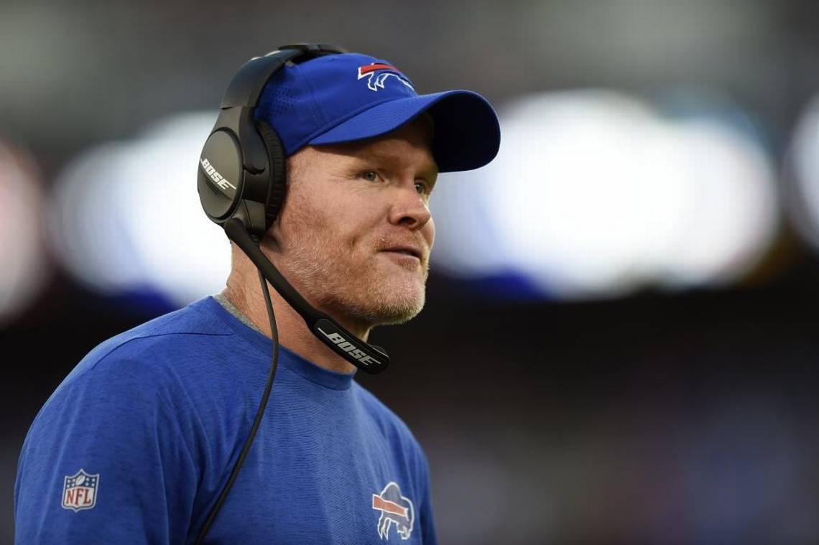
First-year Buffalo Bills coach Sean McDermott spent six seasons as the Carolina Panthers’ defensive coordinator. He’ll return to Charlotte for Sunday’s game against his former team. Gail Burton AP

CAROLINA PANTHERS

Exclusive: Bills coach Sean McDermott talks about how the Panthers shaped him
BY JOSEPH PERSON
jperson@charlotteobserver.com
SEPTEMBER 13, 2017 7:30 AM
Following is Observer NFL reporter Joseph Person’s exclusive interview with first-year Buffalo Bills coach Sean McDermott, who spent the previous six seasons as the Carolina Panthers’ defensive coordinator:
Q. As you were building the program there, what specifically have you taken from your experience here?
A. One of the biggest things is that it's a people-driven business. There's obviously power in human capital and people. Ron (Rivera) does a great job of being around the building and being available to different people throughout the Panthers' organization.
Q. A few years ago he set up a mini-office downstairs and would poke his head into position meetings or the locker room. Is that the type of thing you're referring to?
A. You know what? I do have an office set up in my locker (area). We got that done when I first got here. The players, certainly that was big. Also with Ron was just being available throughout the entire building. Most of the physical structures of these buildings are set up such that players are on one floor and the rest of the staff and coaches are on another. And from a communication and knowing the pulse of the team, that can create a challenge at times.
Q. What else from your time in Carolina has stuck with you in the principles you teach and coach?
A. I would go back to the core values that are instilled on a day-to-day basis by Mr. (Jerry) Richardson in the building. We've tried to develop and communicate our core values here in Buffalo in a similar fashion. I really learned from a business standpoint how important those are. The people -- that's a very unique place. ... One guy that definitely comes to mind in addition to the coaches is the first guy you see when you walk in the building -- it's Mr. (John) Coleman in front in the lobby.
Q. You’ve signed a bunch of former Panthers. How much of what you’re talking about played a part? The idea that you know their skills, but also their makeup?
A. I’ve been around two turnarounds -- one in Philadelphia with Andy (Reid) and then in Carolina with Ron. What I saw up close and personal is both of them brought players in that could help them on the field, but also could help them transition the culture. We’ve got that with Mike Tolbert here and Leonard Johnson and Joe Webb. ...
They’re really important because they know what the standard looks like. We’ve got a bunch of great guys here. We’re just trying to catch up to them down there. What is it, year seven down (for Rivera). And this is Week 2 for us.
Q. Was any part of you dreading this week?
A. I don’t think so. It’s always hard going against friends. There’s that part of it that’s hard. I’ve got nothing but very fond memories of my time in Carolina, both at the Panthers and in the community with the friends we made, our experiences and vacations we took.
Q. How has your familiarity with Brandon Beane helped you with a move you made or decision you guys agreed on?
A. Just the inherent trust that’s been there since Day 1 has been key. Because there’s a lot of time where you spend apart. When I’m coaching the team I’ve got my hands full and Brandon is evaluating us, evaluating the roster. He’ll call me and say, ‘Hey, what do you think about this?’ It’s nice to know you’re already past the part of developing trust. There’s speed and efficiency when you’re working in that range.
Q. Your reaction from afar when Dave Gettleman was fired?
A. You hate to see when that happens. That’s the human part of this business. That was hard to watch. I know I learned a lot personally from Dave. On the other end of it I was happy for Marty (Hurney) because I knew Marty from when I was first there. ... I’m glad the position went to someone I think is very well qualified and I think will do a great job.
Q. Thoughts on game planning for Cam Newton after all the years of being here with him?
A. There’s a reason the Panthers have been successful over the years and Cam Newton’s a big factor in that equation. He does a great job. Mike Shula does a great job and they’ve got a talented team overall. Cam’s very dangerous. He’s a tremendous athlete. He’s dangerous when the ball’s in his hands and he’s got a laser for an arm. I had a front-row seat to watch that for six years.
Q. Is Christian McCaffrey the different kind of weapon the Panthers needed?
A. Wow, he’s a good player. I’ve only had a small exposure to Christian. We watched him coming out of college, did our draft evaluation, just like everybody else. We thought very highly of him coming out. Then you watch what they’ve done with him, he’s another weapon. They’ve got weapons all over the field on offense. We’re going to have our hands full. That can make for a long afternoon.
And then what they’ve done defensively, going and getting Julius Peppers, bringing Captain (Munnerlyn) back, re-sign some key guys. They’re very talented.

