First and Last Name: _________________________________________ Date:___________________ Class: __________
LEDEs for Stories
Directions: Use each photo to create a LEDE. If you’re not sure about a detail, examine the photo and make up the most logical answer (For example, you could say “a group of 8th grade girls” for the first photo). Some of the details have been provided, but not all of them. Fill out the nut graph first, choose a hook second, and then combine the two to create a LEDE.
Remember—LEDEs are 1-2 sentences and range between roughly 30-50 words. Oftentimes, a hook will include pieces of the nut graph, which is normal. Also, the WHY needs to explain the WHAT. The WHO shouldn’t be a specific name because it’s the nut graph—things are unspecific!
LEDE = Hook + Nut Graph (5 Ws, but simpler/unspecific)
- Nut Graph

Who: _______________________________________________________________________________________
What: ______________________________________________________________________________________
Where: Bailey Middle School
When: During PA (physical activity), after lunch
Why: _______________________________________________________________________________________

Hook (circle the one you chose): Contrast Hook Direct Address Hook Picture Hook

LEDE: ______________________________________________________________________________________

___________________________________________________________________________________________

___________________________________________________________________________________________

___________________________________________________________________________________________
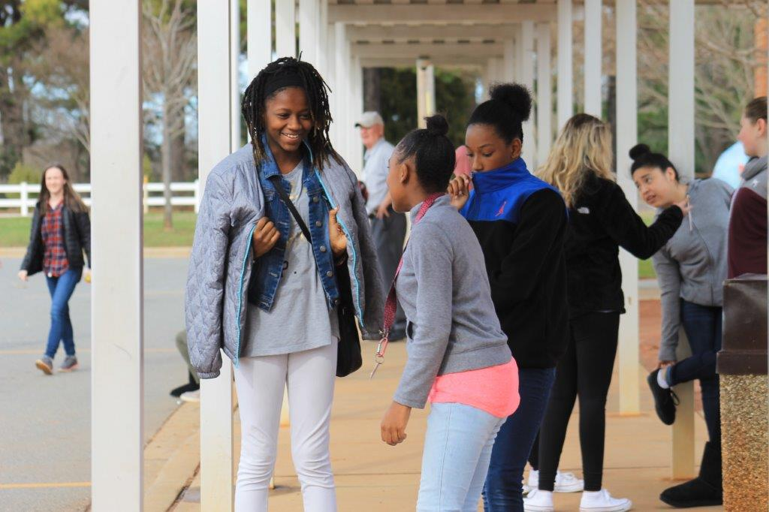

- Nut Graph

Who: _______________________________________________________________________________________
What: the Back-to-School Picnic
Where: Bailey Middle School field
When: ______________________________________________________________________________________
Why: to celebrate the start of the 2017-2018 school year

Hook: Background Hook

LEDE: ______________________________________________________________________________________

___________________________________________________________________________________________

___________________________________________________________________________________________

___________________________________________________________________________________________

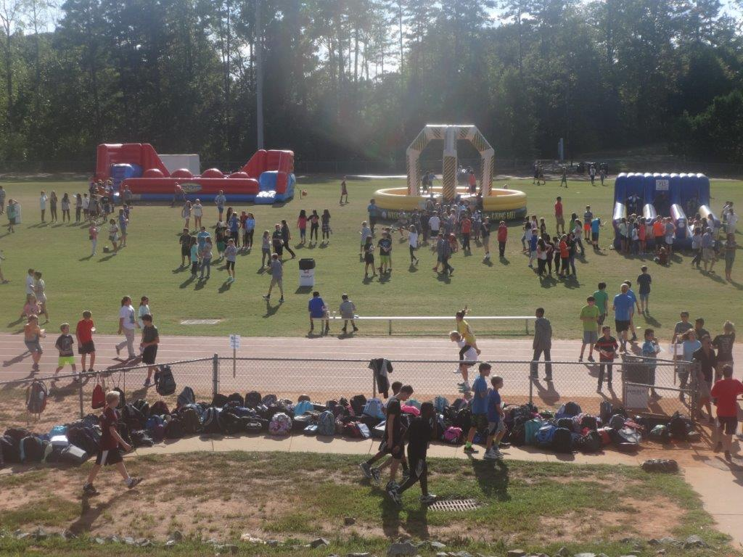

- Nut Graph

Who: the Bailey Middle School band director (Ms. Peterson)
What: conducts her 8th grade band
Where: Bailey Middle School
When: ______________________________________________________________________________________
Why: _______________________________________________________________________________________

Hook I chose: _____________________________________

LEDE: ______________________________________________________________________________________

___________________________________________________________________________________________

___________________________________________________________________________________________

___________________________________________________________________________________________
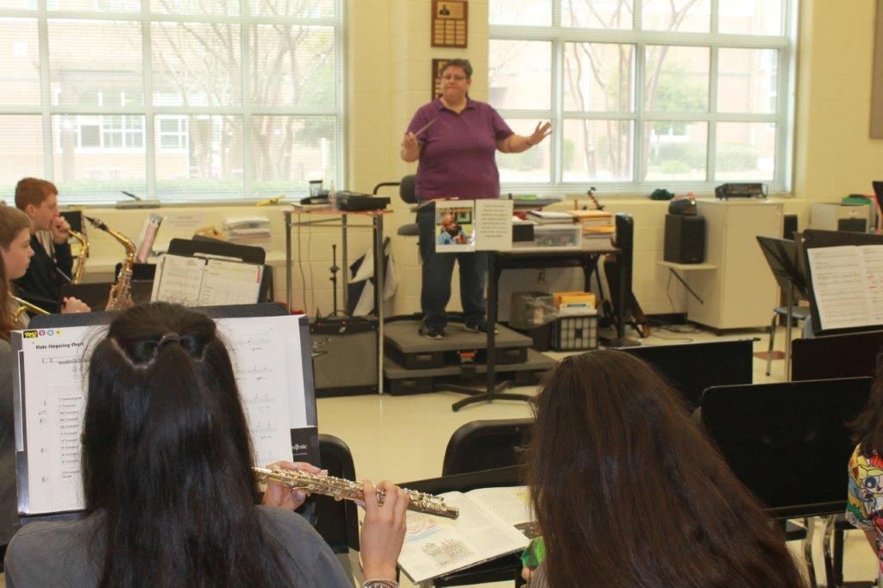

- Nut Graph

Who: _______________________________________________________________________________________
What: grade-level holiday parties
Where: Bailey Middle School
When: December 2016
Why: _______________________________________________________________________________________

Hook I chose: _____________________________________

LEDE: ______________________________________________________________________________________

___________________________________________________________________________________________

___________________________________________________________________________________________

___________________________________________________________________________________________
